Scenario: Book Cruise

|  |  |  |  |
| --- | --- | --- | --- |
|  | Comment | System Event | Response |
| 1 | Validate and Authorize user | Domain:ses.authorize_user(“bob”, “pass”) | Bool == true |
| 2 | Fetch the users role | Domain:ses.get_role(“bob, “pass”) | “customer” |
| 3 | Create the referenced mana object based on factory |  | Book_Cruise* bc = factory::newBookCruise(); |
| 4 | Fetch the commands the user has access to | bc.getCommands(“customer”); | Array of strings(“Book a Cruise”, “Quit”) |
| 5 | Fetch a list of Cruises | bc.CruisesInfo(); | An Array of strings with all the cruises that are in and not in service.  "1. Cuba, 10-May-2020, $5000", "N/A", "N/A" |
| 6 | Book a Room of the Cruise ship that the user selects. | bc.executeCommand(“Book a Cruise”, “1”, 1); | “You have booked one room on the Cruise” |
| 7 | End Session | Domian:ses.signoff() | System exits |

Scenario 1: Book Cruise

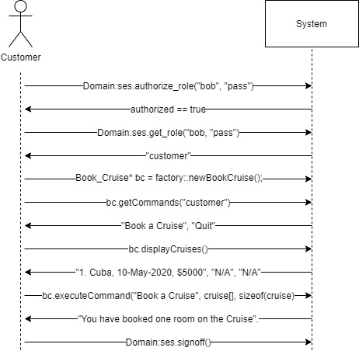

Brief Description:

A user will request to log into the system. The system responds with logging in the user, authenticating the user, generating object, and giving the user commands they can do. The user requests to do Book a Cruise. The system responds with getting all the cruise ships available for booking. The user requests to book one of the ships. The system responds with a confirmation of the booked cruise. The user is then signed off the system.